Name:
Class ID:
Class Hour:

Chapter 10
Mobile Banking, Checks, and Reconciliation

Checking Account Terms:

Check:

Deposit/Withdrawal Slips:

Endorsement:

Check Register:

Deposit Slip:
- You had a rummage sale and deposited all the money: $450.00 in cash, Check #1326 for $150, Check 11800 for $120 (just date it, no signature required).
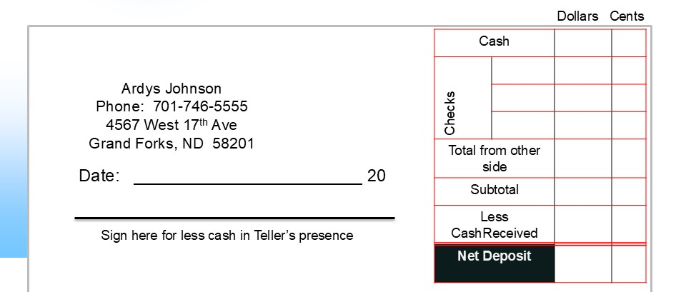
- Check #1345 for $50, Check 1986 for $100. You decide you want some cash in your wallet and request to keep $25.00 cash (date and signature required).

Parts of A Check:
-Circle the Routing Number.
-Put a Box Around the Account Number
-Put an X on the Check Number
The person writing the check is called the or the payer. The person receiving the check is called the . When writing a check, the amount of the check is more binding than the numeric number because the numeric can be hard to read. The memo field is used like a . It just tells you what you spent the money on.
When writing the written amount, write the change as a fraction of over (there are 100 pennies in a dollar so 12/100 as shown below means 12 cents).

Check Endorsements
Blank Endorsement:
Special Endorsement:
Restrictive Endorsement:
Complete from the notes slides shown by your instructor:
Blank Special:
Restrictive

Restrictive you deposit the physical Restrictive for Mobile banking
check at the bank

